MIRAMAR RANCH ELEMENTARY SCHOOL
will celebrate its
30th ANNUAL SUPER JOG-A-THON fundraiser on
Tuesday, March 19th and Wednesday, March 20th 2019

WE NEED YOUR HELP!!
Support us by becoming an
OFFICIAL BUSINESS SPONSOR

Our goal is to raise $30,000
to support science, technology, and art programs for our school.

In recognition of your tax-deductible donation, your business’s logo will be advertised on the back of the 2019 Jog-A-Thon t-shirt given to each of the school’s 700+ students, on a banner at the school field, and on the school website.

Yes, I will be a business sponsor for the 2019 Miramar Ranch Jog-A-Thon

Platinum Sponsor - $1000
Gold Sponsor - $500

Silver Sponsor - $300
Bronze Sponsor - $175

Business Name Contact Person
Phone Number Email Address
Mailing Address

Please return this form by Friday, February 22, 2019 with a check made payable to:
Miramar Ranch FFA
Jog-A-Thon - JC Soman
10770 Red Cedar Drive
San Diego, CA 92131

Or pay on-line at www.jogathon.miramarranch.org/official-sponsors.

Please contact JC Soman for more information: jurate1114@gmail.com or (248)-854-7142

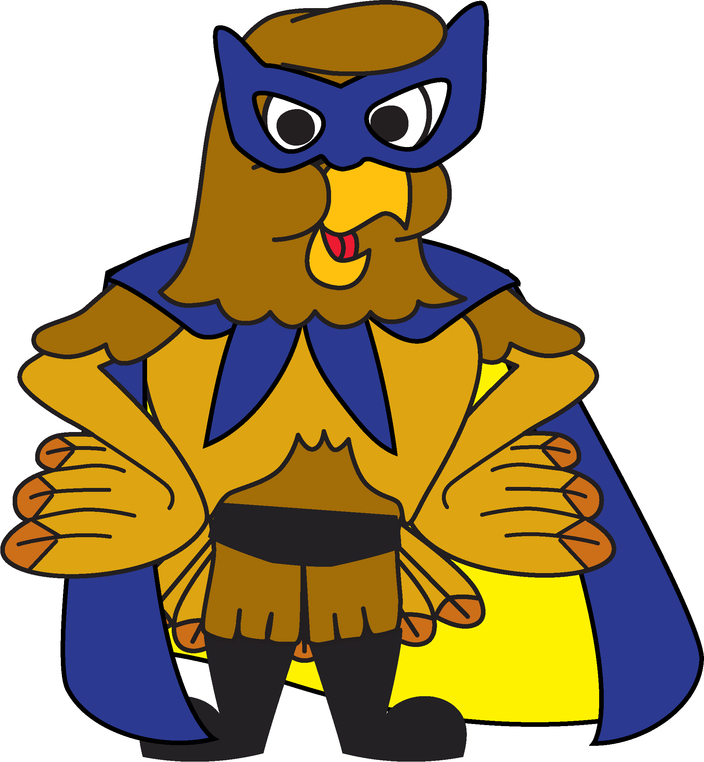
The Miramar Ranch FFA is a 501(c)(3) non-profit
dedicated to excellence in education.

THANK YOU FOR YOUR SUPPORT!!!

